LAWFIT CHALLENGE AGILITY COURSE

Using laser targeting system
fire & hit target. A successful
shot stops the clock.

Handcuff Suspect Run 50 yds
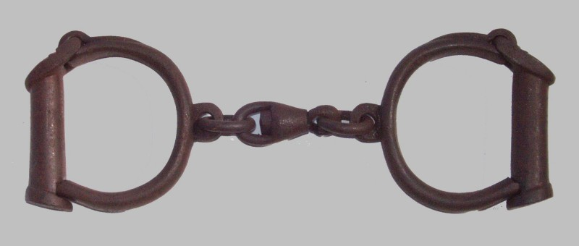
Officer is given a physical
description of a suspect. Run 20 yds Time begins when
Drag Victim monitor says “GO”.
START
5 yds
150 lbs
Run 25 Run 15 yds yds

1 2 3 4
Jump 3 ft
Identify Suspect

Run 10 yds Run 25
yds

Run 15 yds
Run 10 yds
Run 25 yds
Climb 8” step up
Climb through window and down twelve Climb over
36”w X 30”h X 3’ (12) times Crawl under 5 ft obstacle
above the ground (motion must be obstacle
up/up – down/down) 2’h X 10’l

