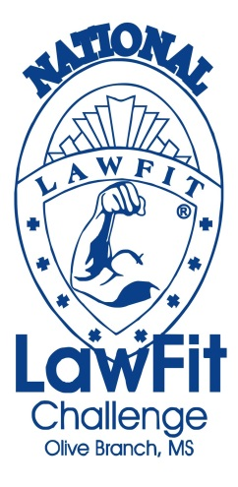

June 19-21, 2014

Hosted by:

Olive Branch Police Department
Mississippi Law Enforcement Officer’s Training Academy
Mississippi Highway Patrol
LawFit Program at George Mason University

www.lawfit.org www.obms.us

