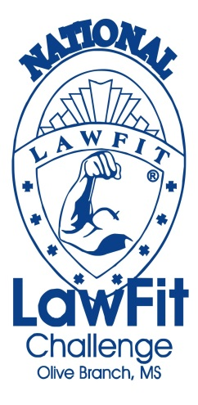
June 19-21, 2014

The LawFit Challenge consists of a series of six fitness and job related competitive events:

- One Repetition Maximum Bench Press (Based on Percentage of Body Weight)
- One Minute Timed Sit-Up Test
- Sit and Reach Flexibility Test
- Pull-Ups
- 1.5 Mile Run
- 200 Yard Agility Course (Suspect Pursuit)

Scores for the event are age and gender adjusted to provide a fair and equitable competition for all participants.
All competitors will receive a variety of gifts and fitness gear from sponsoring companies.

Additional Info: www.lawfit.org www.facebook.com/obpolice www.obms.us

Who can participate? We’re inviting all law enforcement agencies in the United States.

Registration Fee: $75 Per Participant ($85 for late registration after June 2, 2014)

Deadline: Entries must be registered by June 2, 2014

Hotel Registration: Competitors should reserve their rooms by calling:
Whispering Woods Hotel & Conference Center, Olive Branch, MS
Call Group Reservations toll free @ (866)-851-0393 or (662)-895-2941. Mention “National LawFit Challenge” to receive the group rate of $75.00 per night. Reservations should be made by May 19, 2014.

For further information, please contact:
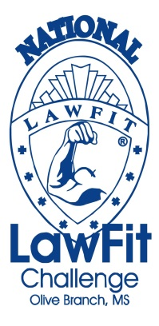
Capt. Thomas Tuggle - 601-933-2129 - mrt2usmc@msn.com
Lt. LeAnn Farr - 662-420-9911 - lfarr@obms.us
OR
Dr. Dave Bever (George Mason University) at 703-993-2071

Awards will be presented to the top teams & top competitors in the following categories:

* Overall Individual Male and Female
* 4-Man Team
* 4-Person Mixed Team (2-Men/2-Women)
* Men’s Pairs and Women’s Pairs
* Mixed Pairs (1-Man/1-Woman)
* Individual Event Winners

**Each competitor will compete in all events.
Participants’ scores will be combined for the team categories.

