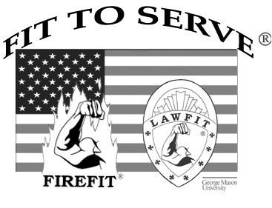
NATIONAL CENTER FOR PUBLIC SAFETY FITNESS

20 February 2013
Attention: Law Enforcement Fitness Leaders,

As Director of the National Center for Public Safety Fitness at George Mason University, I would like to invite you and your agency’s training personnel to participate in our April 16-18, 2013 LawFit Fitness Leadership Workshop at the Roanoke Police Academy in Roanoke, Virginia. This workshop will provide your personnel with information concerning the Virginia Department of Criminal Justice Services’ job-validated physical abilities course and the National Center’s fitness tests developed for academy recruits and incumbent officers. Workshop participants will have the opportunity to learn a variety of assessment skills and training strategies for planning and implementing effective health maintenance programs for their agencies.

Cost for the workshop, course materials, and certification is $400.00 per person. If two or more of your agency’s officers participate, the registration fee is reduced to $300.00 per person. Housing and meals are the responsibility of participants. We have enclosed a workshop registration, information concerning participant training gear, lodging, and directions to the Roanoke Academy.

I encourage you to take advantage of this opportunity to provide cutting-edge health and wellness for your agency’s law enforcement personnel. Since there are limited spaces available in this workshop, mail or fax your registration as soon as possible to the National Center for Public Safety Fitness at the address listed on the registration form. Checks should be made payable to: LAWFIT.

The National Center for Public Safety Fitness looks forward to working with you and your agency. If you have any questions, please feel free to give us a call.

Sincerely,

Dr. Dave Bever

Director - National Center for Public Safety Fitness
Recreation and Athletic Complex, Room 2107, MS 1F6
George Mason University
Fairfax, VA 22030
703-993-2071
dbever@lawfit.org
fax :703-993-2126
www.lawfit.org

