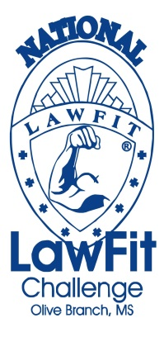

Participation in the 2013 National LawFit Challenge provides an excellent opportunity for your organization to support the law enforcement community while providing a showcase for your products.
Your financial support of this unique and powerful event is greatly appreciated.

SPONSORSHIP LEVELS
Diamond Sponsorship $3500 and Above
- Official Sponsor
- One of the Events will be titled with your Company Name (ex Homer Skelton Lawfit Bench Press)
- Company Representative will present the award for the event titled in its name
- High Profile in all Media and Advertising for Event
- Name and Company Logo on Event Brochure
- Name and Company Logo on Websites: LawFit, OB Police, and Facebook
- Name and Company Logo on Event T-Shirts
- Official Event Polo Shirt
- Official Event T-Shirt
- Company Name/Logo on Banner at Event
- Opportunity of Placing Promotional Item in Competitors Gift Bag
- Official DVD of Entire Event
- Plaque Presentation and Recognition as Diamond Sponsor at Banquet

Platinum Sponsorship $2500 - $3499
- Name and Company Logo on Event T-Shirts
- Official Event T-Shirt
- Company Name/Logo on Banner at Event
- Official DVD of Entire Event
- Plaque Presentation and Recognition as Platinum Sponsor at Banquet

Gold Sponsorship $1500 - $2499
- Name and Company Logo on Event T-Shirts
- Official Event T-Shirt
- Official DVD of Entire Event
- Recognition at Banquet

Silver Sponsorship $500 - $1499
- Company Name on Event T-Shirts
- Official Event T-Shirt
- Official DVD of Entire Event

Bronze Sponsorship $25 - $499
Company Name on Event T-Shirts
- Official Event T-Shirt

