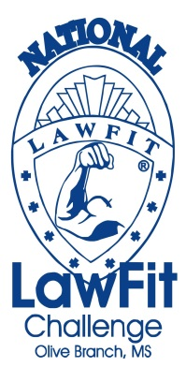

SPONSORSHIP FORM

I/We (Sponsor) would like to help the Olive Branch Police Department and the Mississippi Law Enforcement Officers’ Training Academy with the 2013 National LawFit Challenge, located in Olive Branch, MS, by donating to the June 13-15, 2013 competition as indicated below (Non-profit Tax ID No. provided upon request):

SPONSORSHIP LEVELS:

____$3500 – Above - Diamond Sponsor
____$2500 - $3499 - Platinum Sponsor
____$1500 - $2499 - Gold Sponsor
____$500 - $1499 - Silver Sponsor
____$25 - $499 - Bronze Sponsor

I (Sponsor) have enclosed a tax-deductible amount of $_____________________ to help sponsor the June 13-15, 2013 National LawFit Challenge at the level checked above.

Please complete this form and submit your Sponsorship Donation by May 17, 2013. Make check payable to: Friends of Olive Branch and mail to: 9200 Pigeon Roost Olive Branch, MS 38654. On the memo line of your check and on the envelope, please note “2013 National LawFit Challenge”. You may also contact Sgt Swindall or Sgt. Farr directly to have your sponsorship check picked up.

For inquiries, call Sgt. Lawrence Swindall at 901-233-1235 or Sgt. Farr at 662-420-9911.

Contact Person: _____________________________ Shirt Size: ________

Organization: _________________________________________________

Organization Address: __________________________________________

Organization Ph#: ______________________________________________

Email Address: ________________________________________________________________________

Thank you very much for helping the 2013 National LawFit Challenge!

For more information, visit www.lawfit.org and www.obms.us

