♣ Sponsoring Site: George Mason University Field House

Thursday, October 13, 2011

- 6:30pm – 7:30 pm Registration and Weigh-in
- 7:30 pm – 8:00 pm Welcome and Rules Interpretation
- 8:00 pm – 10:30 pm Bench Press Competition

Friday, October 14, 2011

- 8:30 am - 9:00 am Check-in

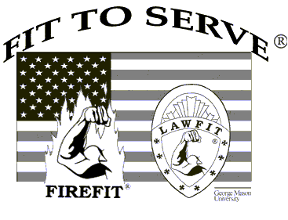
- 9:00 am - 9:45 am Opening Ceremonies
Welcome & Introductions
Moment of Silence
National Anthem
9:45 am - 10:00 am Warm-up

- 10:00 am – 3:00 pm Event Testing
1. 1 minute timed sit-ups
2. Sit & Reach
3. Pull-ups
4. 1.5 mile run

- 5:00 pm – 9:00 pm Happy Hour/LawFit Social
ICONS Sports Lounge and Grille
10418 Main St. -- Fairfax, VA – 703-865-6101

Saturday, October 15, 2011

- 9:00 am- 9:15 am Check-in
- 9:15am – 9:45 am Suspect Pursuit Walk-through
- 10:00 am – 1:00 pm Suspect Pursuit Competition
- 1:00 pm - 1:30 pm Team Pictures
- 5:30 pm – 6:30 pm LawFit Happy Hour
- 6:30 pm Celebration/Awards Banquet
- 9:30pm Music/Party/Dancing

- The Auld Shebeen
3971 Chain Bridge Road
Fairfax, Virginia 22030
703-293-9674

